**Experiment Title**

**Student Name:**Rahul Kumar Singh **UID:** 19BCS8016

**Branch:** CSE **Section/Group:**20-A

**Semester:** 5th **Date of Performance:**23rd July 2020

**Subject Name:** Design & Analysis of Algorithms Lab  **Subject Code:** CSP-309

**1. Aim/Overview of the practical:**

Code to compute the greatest common divisor(GCD) of two numbers

**2. Task to be done/ Which logistics used:**

Using Euclid’s algorithm to calculate the greatest common divisor(GCD)

**3. Algorithm/Flowchart (For programming based labs):**

Step1: if n==0,return m and stop;

Otherwise go to step 2

Step2: Divide m by n and assign the value of the remainder to r.

Step3: Assign the value n to m and value of r to n

go to step 1

While n=! 0 do

R<-m mod n

m<-n

n<-r

return m

**4. Steps for experiment/practical/Code:**

def euclid(x, y):

while(y):

x, y = y, x % y

return x

a = 60

b= 24

# prints value or r now....

print ("The gcd of 60 and 24 is : ",end="")

print (euclid(60,24))

**5. Observations/Discussions/ Complexity Analysis:**

Middle-school procedure complexity is O(√n)

Consecutive integer checking method complexity is O(n)

Euclid’s method complexity is O(log n)

**6. Result/Output/Writing Summary:**

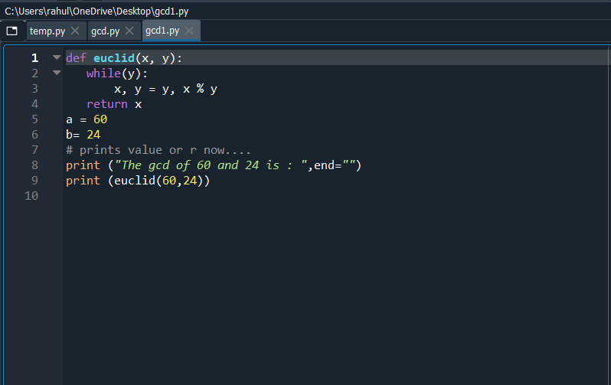

**Output:**

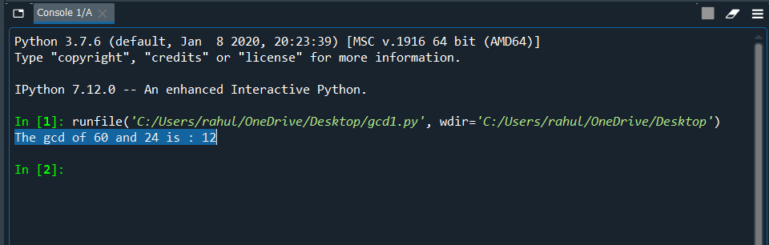

**Learning outcomes (What I have learnt):**

**1.** Learn that how to program euclid’s algorithm**.**

**2.**we canquickly find the GCD of 2 integers using this method

**3.** This will take less time complexity ( O(log n))

**Evaluation Grid (To be created as per the SOP and Assessment guidelines by the faculty):**

| Sr. No. | Parameters | Marks Obtained | Maximum Marks |
| --- | --- | --- | --- |
| 1. |  |  |  |
| 2. |  |  |  |
| 3. |  |  |  |
|  |  |  |  |